Name Quang Huynh

**Inquiry Lab Form (Muscle Fatigue)**

*Problem: What factors affect muscle contraction?*

*Background:*

*Understand cellular respiration and what is required for muscles to contract.*

*Independent Variable*: (*what will you test?)*

**You Vs…**

*Dependent Variable: (what changed because of the factor from above?))*

Number of contractions per 30 seconds.

*Constants:*(what needs to remain the same to keep your experiment fair?)

1. 30 second increments 6. Same test tube holder

2. Total time of 150 seconds 7. No rest times

3. Each second is the same as the last 8. Same temperature

4. Same hand/finger is used 9. Same arm position

5. No half reps, only full reps 10. Atmospheric conditions

11. Ideally – diet, sleep and others 12. Handedness (dominant hand)

*Procedure / Hypothesis: (what will your experiment look like? what will happen?)*

**If time increases,**

**then the reps would weaken/get less other time.**

*Data: (make a data table to record your results and observations, remember to include both heartrate and breathing rate for each type of exercise compared to your resting rate.)*

|  |  |
| --- | --- |
| **Time** | **Reps** |
| **30** | **102** |
| **60** | **80** |
| **90** | **69** |
| **120** | **51** |
| **150** | **43** |

**Graph:** (Insert a graph that shows the results of your experiment. Show the heartrate and breathing rate for each exercise compared to your resting rates)

**A screenshot of a cell phone

Description generated with high confidence**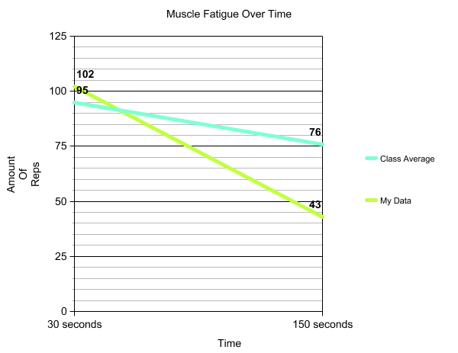

**Explanation / Conclusions:**

Claim:

When time increases, the amount of reps decreases gradually.

Evidence:

From the graph and data table, it shows that over time, the reps start to decrease. At the 30 second mark, the amount of reps was 102. But then, 30 seconds later, at the 60 second mark, the amount of reps decreased by 22, otherwise there were 80 reps when 60 seconds came around.

Reasoning:

Due to the muscle fatigue that you get, your reps decrease over time since the force of your muscles’ movements are decreased, and that makes you weaker/tired. So, because of this, the amount of reps is going down over time.